Update the classes from the Leah_Nicholson_objects.py file

implement some of the methods of the Blackjack class from blackjack.py file

Here are detailed instructions:[Project-Phase2.pdf](https://bc.instructure.com/courses/2528645/files/271255321?wrap=1)

Submit edited versions of objects.py and blackjack.py

with block-comment at the top

Sample run 1

Player sets a valid bet amount

enters 'hit' once

program ends because player busts with 22 points

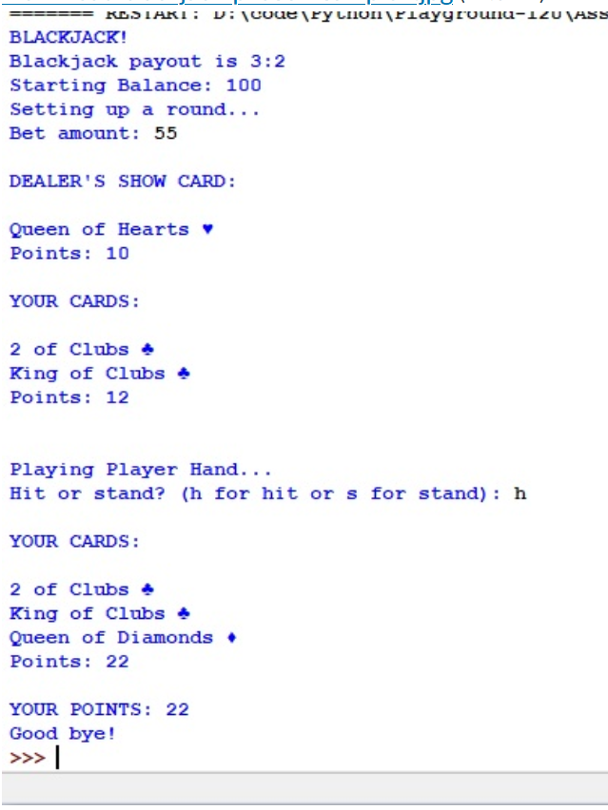

Sample run 2

Player sets a valid bet amount

enters 'hit' once

has 18 points and decides to 'stand'

Program ends

Note here Ace is counted as 11 points since that doesn't take the total points of the hand over 21.

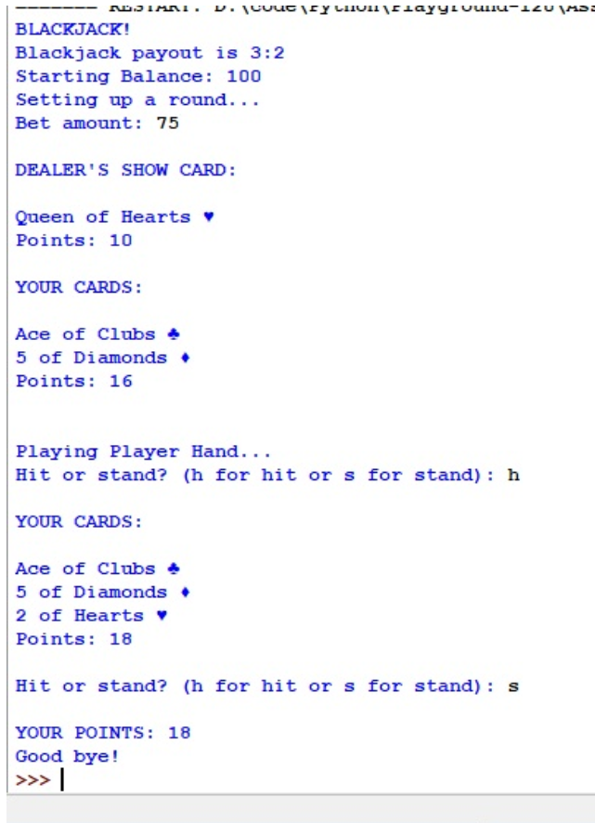

Sample run 3

Player enters invalid bet amount a couple of times

Finally enters a valid bet amount

enters 'hit' a few times

and finally enters "stand" when reaches 19 points

Program ends

Note that initially the Ace is counted as 11 points, but with the addition of  more cards, the Ace is counted as 1 point keeping the hand total under 21.

